Press Release: For immediate release
National Police Service Partnership with Simba Corp
sees 30 New Proton X70 SUVs added to the Police Fleet

Nairobi, November 19th,2021: Simba Corp today officially handed over 30 brand new Proton X70 SUVs to the National Police Service at a ceremony held at the Simba Corp Headquarters on Mombasa Road.
The National Police Service over the last few years has been modernizing its fleet through the government leasing program.
Speaking at the event, Julius Sunkuli, Director logistics DCI said “We are happy to add to our fleet 30 new Proton X70’s; a very modern, fast, and comfortable SUV that will be useful in maintaining law and order, and crime-fighting activities across the country. We have been leasing vehicles for some time now to increase efficiency in the police force which in turn ensures we are always available to serve Kenyans.”
Proton Product Manager, Faruk Alibhai, stated that the Proton X70 is a versatile vehicle with top-of-the-line features that make it a suitable vehicle for the police force. With a fully functional service centre with trained personnel, Simba Corp will be able to service the entire fleet across the country through its branches, dealers, and numerous service centres countrywide.
Nixon Oduor, Head of Government Sales and Leasing at Simba Corp gave his remarks during the event, “This partnership with National Police Service marks a milestone for Simba Corp. We are grateful that the National Police and other Government agencies are now able to lease brand new vehicles of international standards to aid in their service delivery. We are proud to be part of this,” he said.
On his part, Simba Corp Group CEO, Dinesh Kotecha added, “Simba Corporation is committed to the Government’s agenda of increasing local manufacturing and will therefore continue increasing local assembly of motor vehicles, creating job opportunities and offering zero mileage new vehicles at affordable prices to Kenyans. We produce the first fully locally assembled saloon car, the Proton SAGA at our assembly plant, Associated Vehicle Assemblers (“AVA”) in Mombasa.
He added, “We are proud to introduce the Proton brand into the Kenyan market and will be continuing to grow and expand the Proton Model range to target different segments of the market.”
In December 2020, His Excellency the President Hon. Uhuru Kenyatta, officially launched the Proton Saga in Kenya at the AVA plant in Mombasa. He proudly mentioned that Kenyans can now purchase a brand-new vehicle, at the same price of an equivalent 8-year second-hand vehicle. The President lauded the move which also stimulates economic growth by creating jobs for Kenya’s youth.
-ENDS-
For media inquiries, please contact:
Paul Karingithi |Brandspark PR |paul.karingithi@brandspark.co.ke | Tel: 0721678828

About Simba Corp
Simba Corporation is an integrated business group headquartered in Nairobi, Kenya with interests in such diversified businesses such as local assembly of Motor Vehicles, Sales and Service of several global motor brands, Hospitality, Investment and Financial Services. Simba Corporation has been in business for 53 years having grown from a modest used-car sales enterprise, into one of Kenya's most successful indigenous commercial organization. Brands distributed by Simba Corporation includes Mitsubishi, Mahindra, Fuso Trucks and Buses and SAME Tractors. Simba Corp. is a member of KAM (Kenya Association of Manufacturers), KEPSA (Kenya Private Sector Alliance), KMI (Kenya Motor Industry Association), FKE (Federation of Kenya Employers), among others, and in 2016, signed the code of Ethics for business in Kenya under the United Nations Global Compact Network- Kenya.
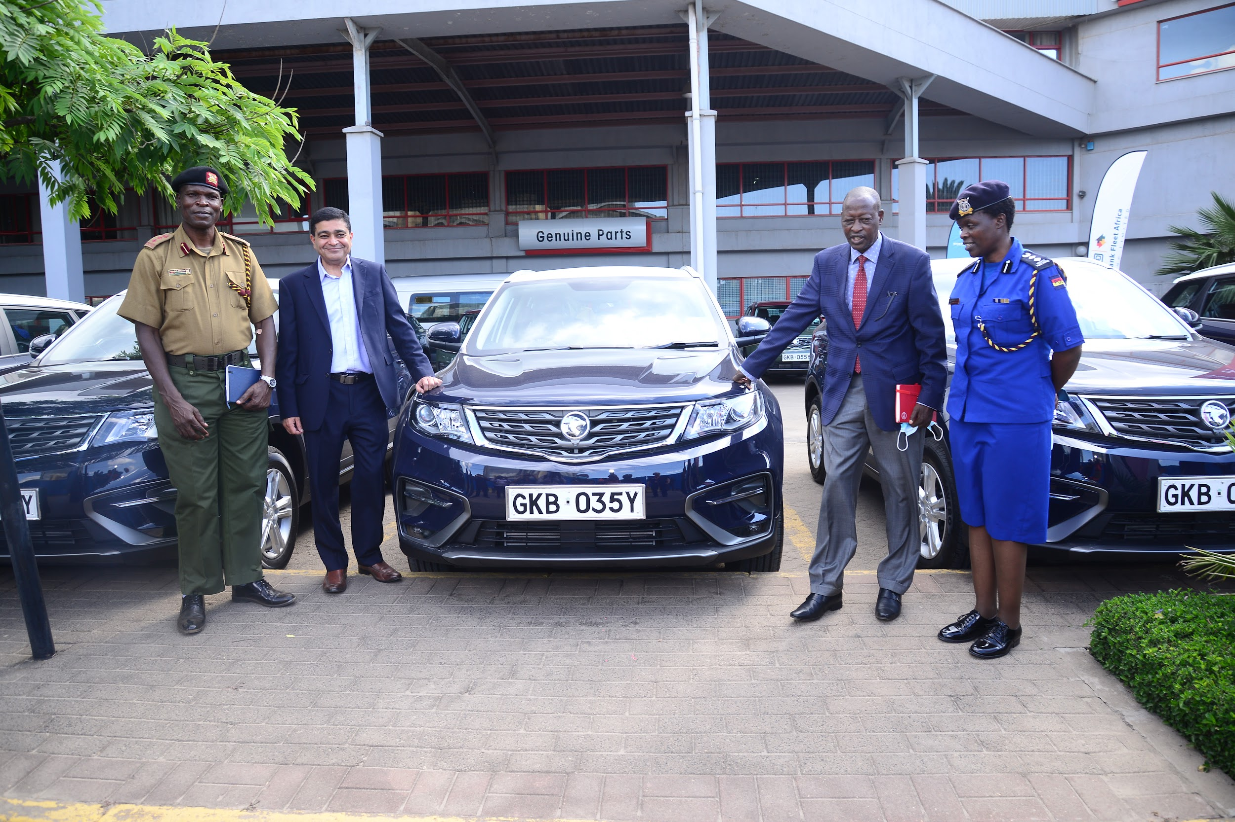

Video: https://drive.google.com/file/d/1IVp7hnSTfTGmURe9E6UJLdQydC_aPyvw/view?usp=sharing
Proton Product Manager, Faruk Alibhai explains the features of the new proton X70 to representatives from the Administration Police during the handover of 30 Brand new Proton X70 vehicles from Simba Corp to the Police in a leasing agreement with the Cooperative Bank Fleet Africa Leasing Ltd.
Flag-Off Video: https://drive.google.com/file/d/1kfX0vim2rR3Qj9gddMC73pRIfn8NYw8B/view?usp=sharing
Branded Police Proton X70 Video: https://drive.google.com/file/d/1BI-S-vymJX0smkPGeMVNJeyXAg1vS5pj/view?usp=sharing
Sample Vehicle photos:
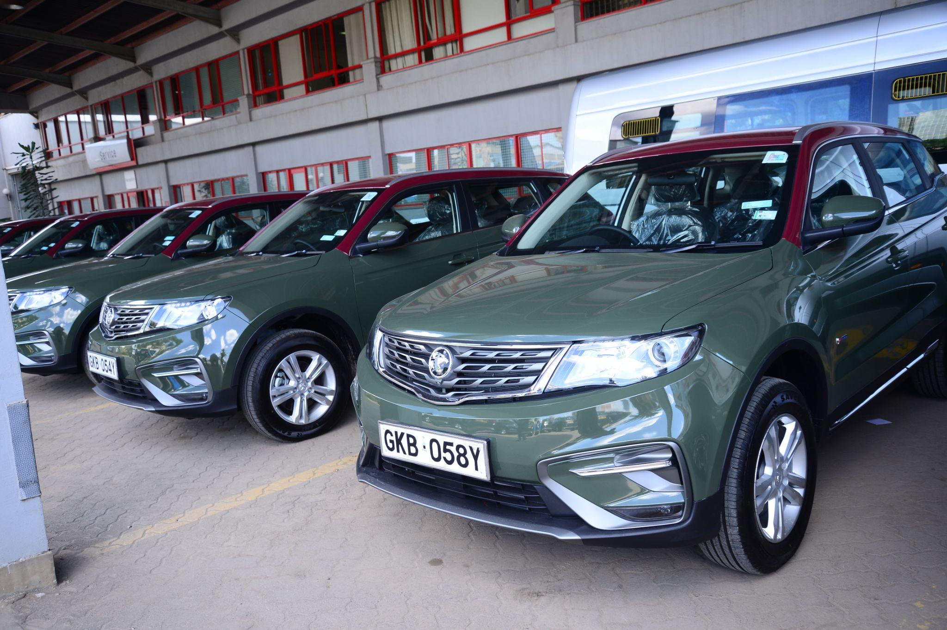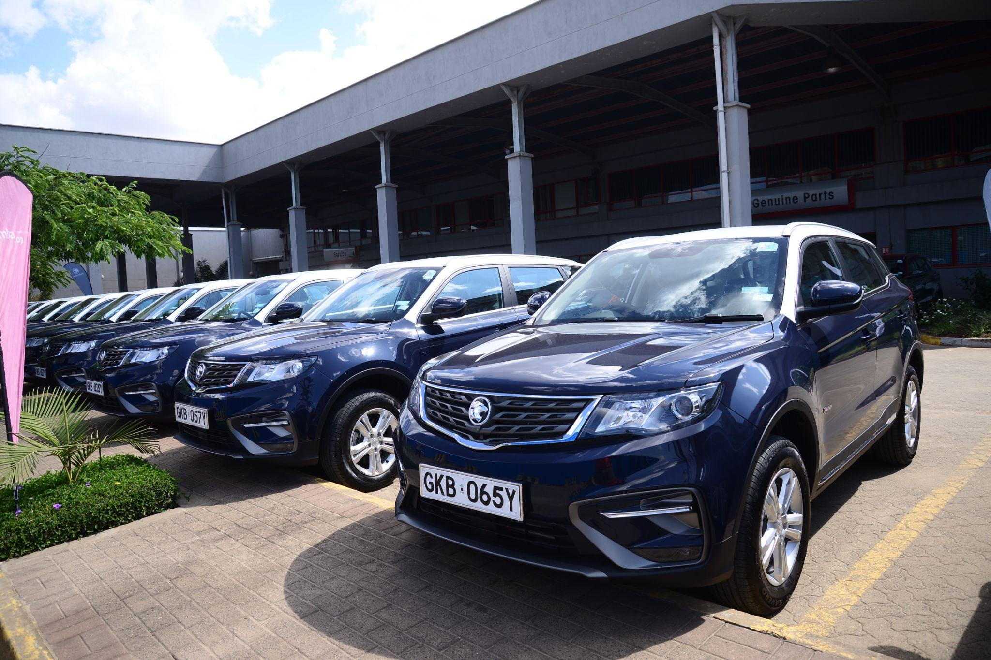
All selected photos and video: https://drive.google.com/drive/folders/1ayiMxHe77OFrWRCLaiPgmnTpbIRyHLqQ?usp=sharing

